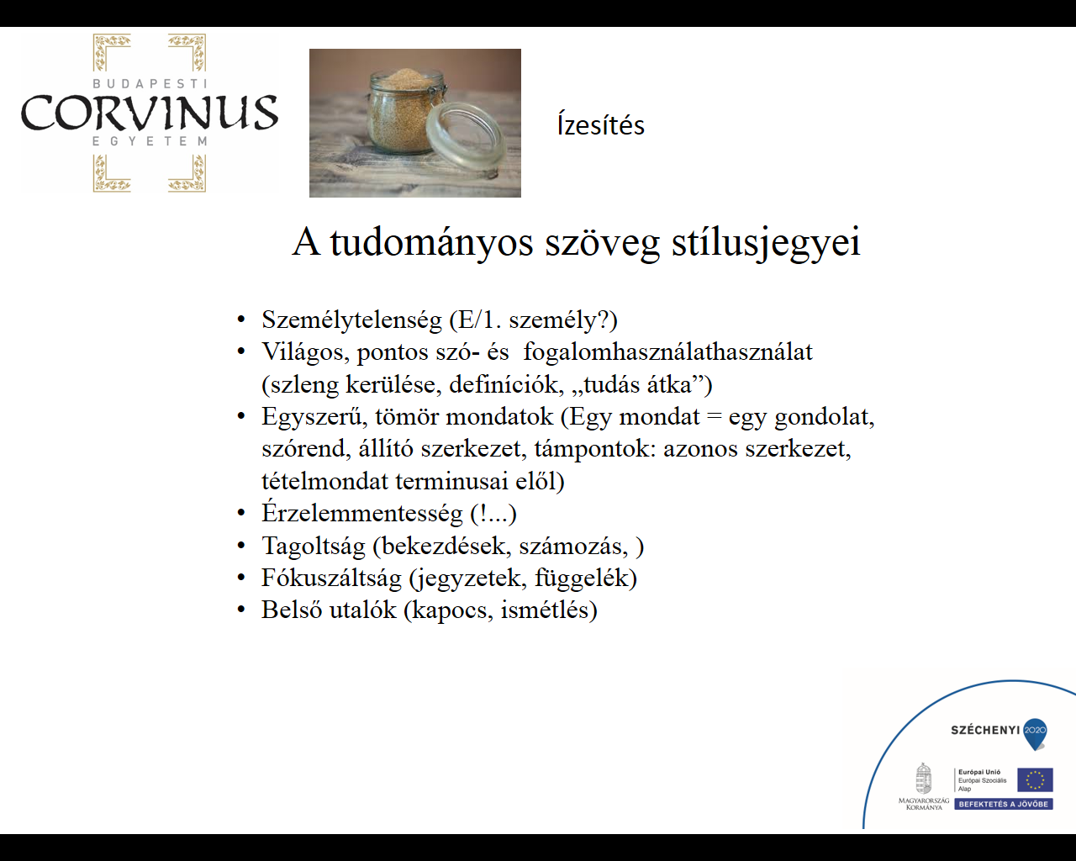

Jegyzetek

------------------------------------------------------------------------------------------------------------------------------------------------------------------------------------------------------------------------------------------------------------------------------------------------------------------------------------------------------------------------------------------------------------------------------------------------------------------------------------------------------------------------------------------------------------------------------------------------------------------------------------------------------------------------------------------------------------------------------------------------------------------------------------------------------------------------------------------------------------------------------------------------------------------------------------------------------------------------------------------------------------------------------------------------------------------------------------------------------------------------------------------------------------------------------------------------------------------------------------------------------------------------------------------------------------------------------------------------------------------------------------------------------------------------------------------------------------------------------------------------------------------------------------------------------------------------------------------------------------------------------------------------------------------------------------------------------------------------------------------------------------------------------------------------------------------------------------------------------------------------------------------------------------------------------------------------------------------------------------------------------------------------------------------------------------------------------------------------------------------------------------------------------------------------------------------------------------------------------------------------------------------------------------------------------------------------------------------------------------------



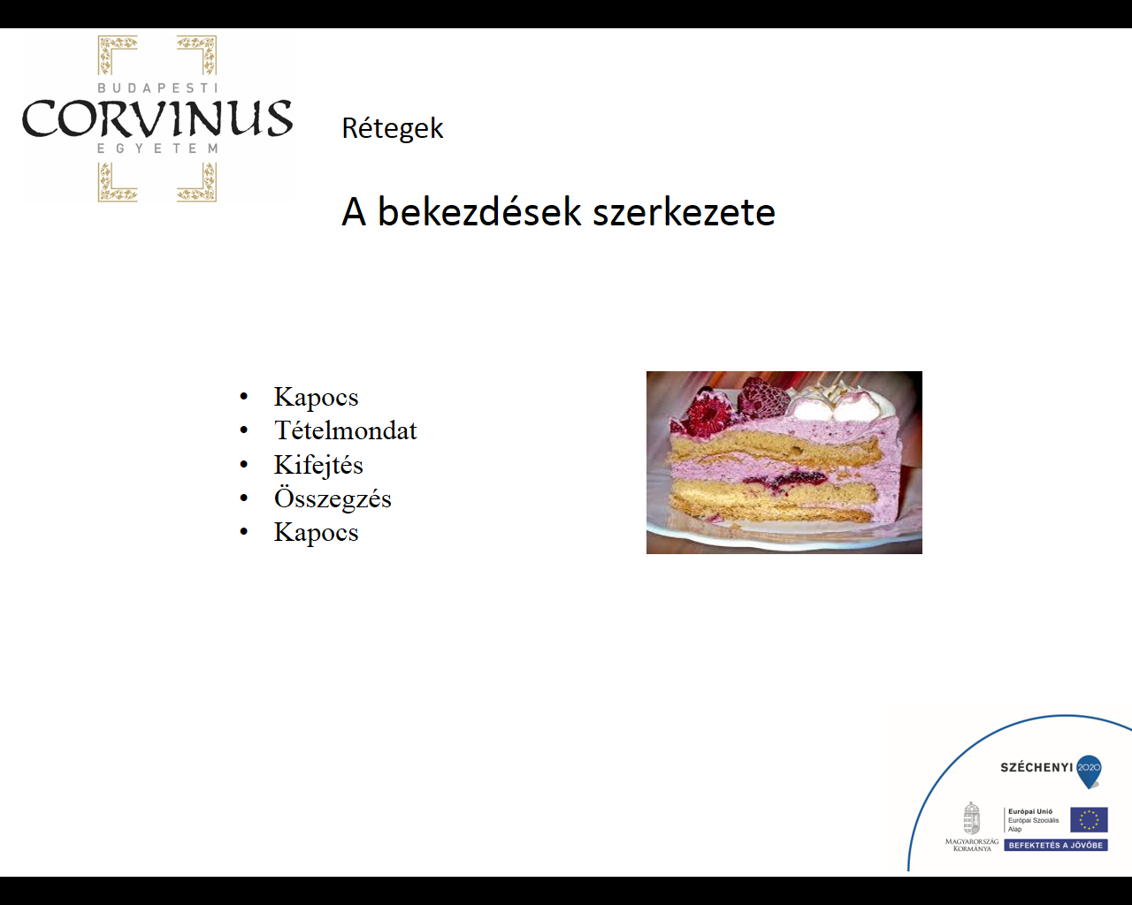

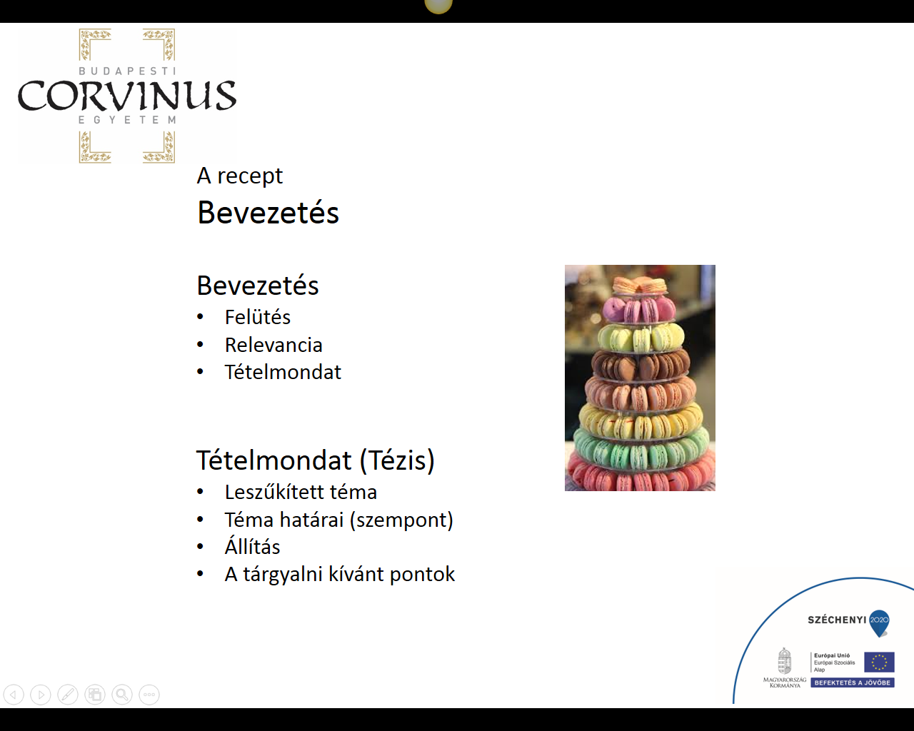

Jegyzetek

-------------------------------------------------------------------------------------------------------------------------------------------------------------------------------------------------------------------------------------------------------------------------------------------------------------------------------------------------------------------------------------------------------------------------------------------------------------------------------------------------------------------------------------------------------------------------------------------------------------------------------------------------------------------------------------------------------------------------------------------------------------------------------------------------------------------------------------------------------------------------------------------------------------------------------------------------------------------------------------------------------------------------------------------------------------------------------------------------------------------------------------------------------------------------------------------------------------------------------------------------------------------------------------------------------------------------------------------------------------------------------------------------------------------------------------------------------------------------------------------------------------------------------------------------------------------------------------------------------------------------------------------------------------------------------------------------------------------------------------------------------------------------------------------------------------------------------------------------------------------------------------------------------------------------------------------------------------------------------------------------------------------------------------------------------------------------------------------------------------------------------------------------------------------------------------------------------------------------------------------------------------------------------------------------------------------------------------------------------------------------------------------------------------------------------------------------------------------------------------------------

