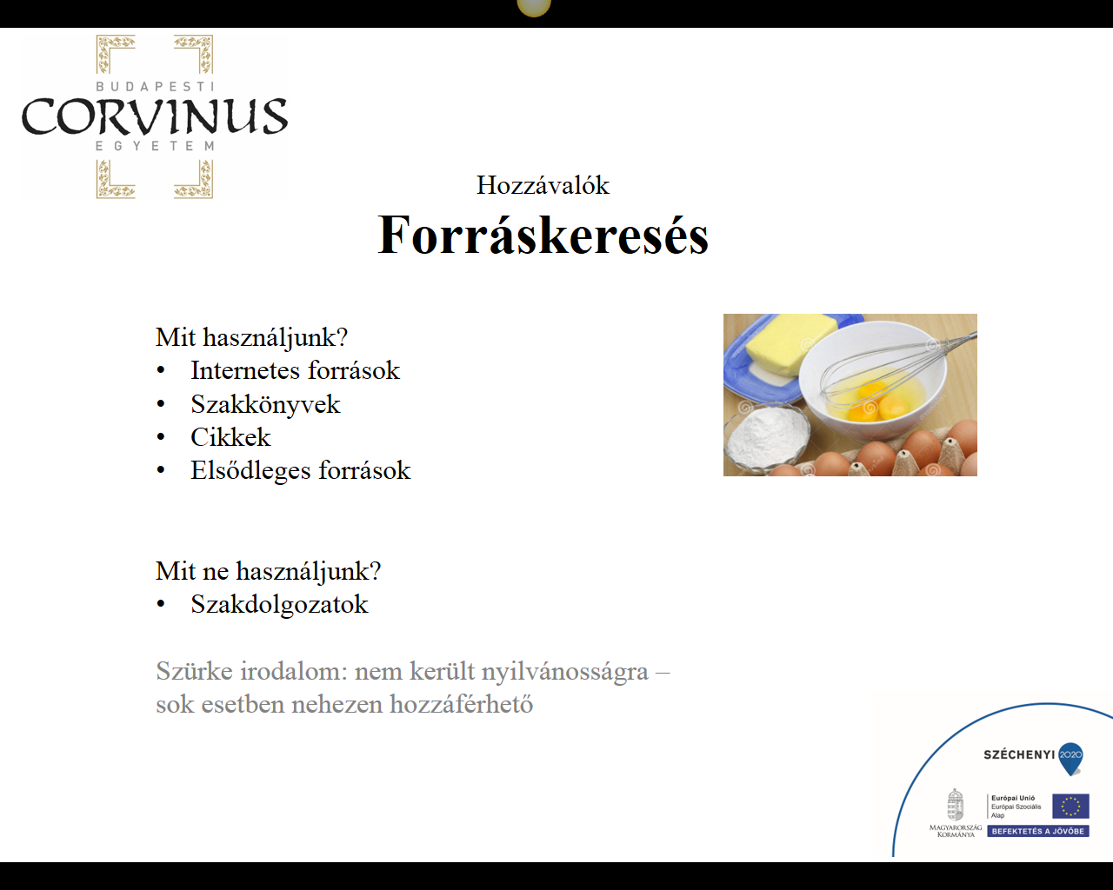

Jegyzetek

---------------------------------------------------------------------------------------------------------------------------------------------------------------------------------------------------------------------------------------------------------------------------------------------------------------------------------------------------------------------------------------------------------------------------------------------------------------------------------------------------------------------------------------------------------------------------------------------------------------------------------------------------------------------------------------------------------------------------------------------------------------------------------------------------------------------------------------------------------------------------------------------------------------------------------------------------------------------------------------------------------------------------------------------------------------------------------------------------------------------------------------------------------------------------------------------------------------------------------------------------------------------------------------------------------------------------------------------------------------------------------------------------------------------------------------------------------------------------------------------------------------------------------------------------------------------------------------------------------------------------------------------------------------------------------------------------------------------------------------------------------------------------------------------------------------------------------------------------------------------------------------------------------------------------------------------------------------------------------------------------------------------------------------------------------------------------------------------------------------------------------------------------------------------------------------------------------------------------------------------------------------------------------------------------------------------------------------------------------------------------------------------------------------------------------------------------------------------------------------------------------------------------------------------------------------------------------------------------------------------------------------------------------------------------------------------------------------------------------------------------------------------------------

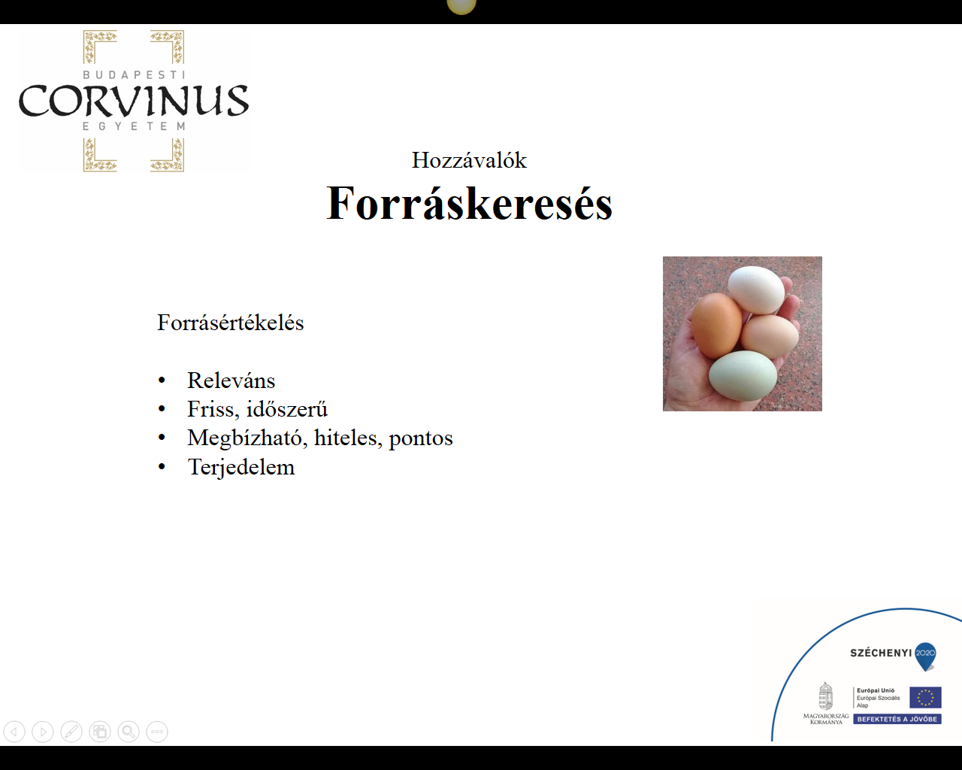

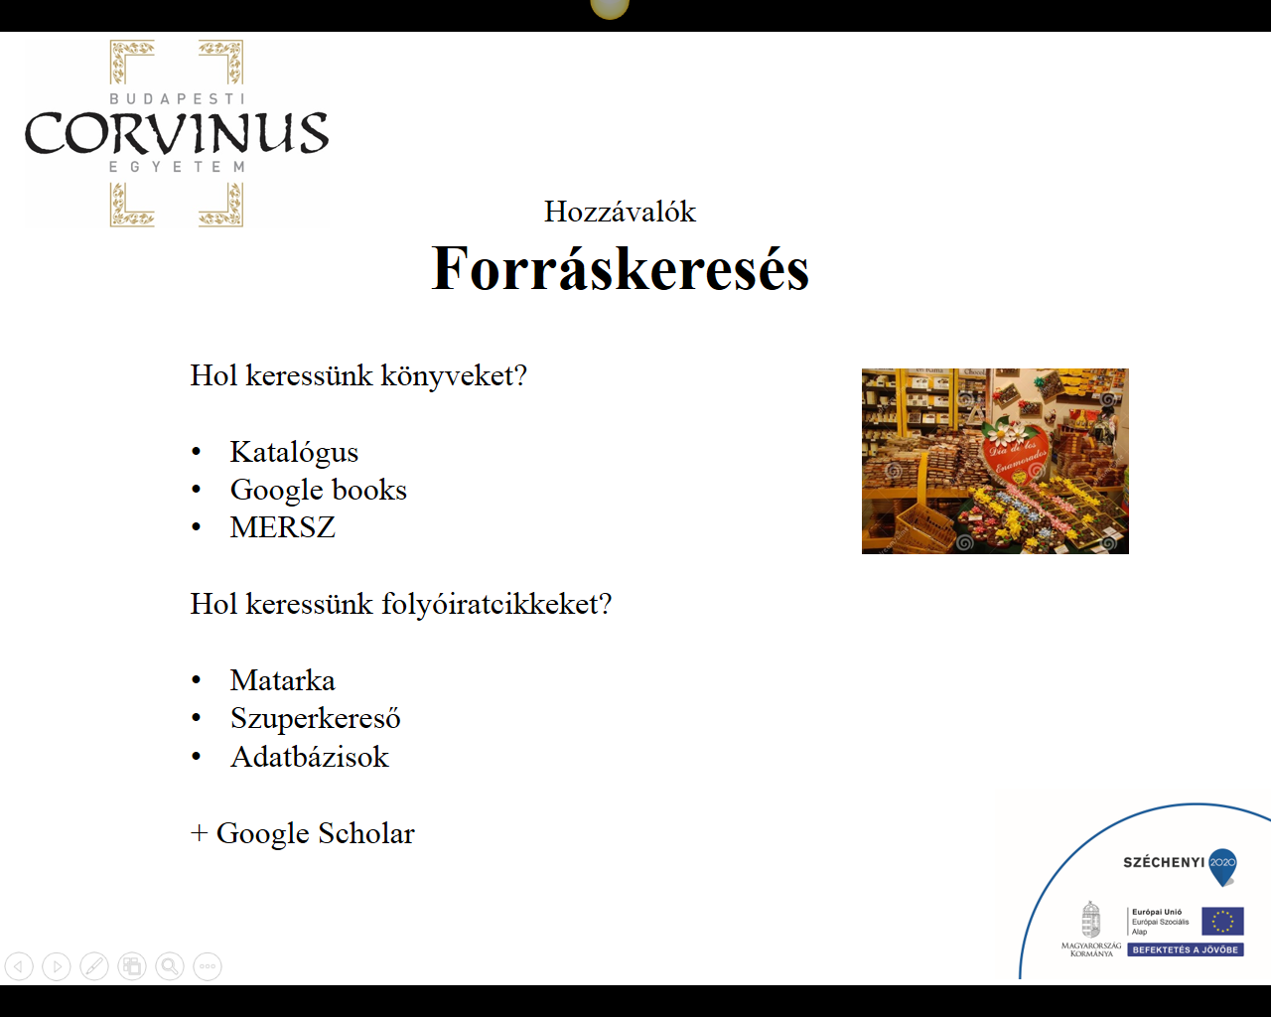

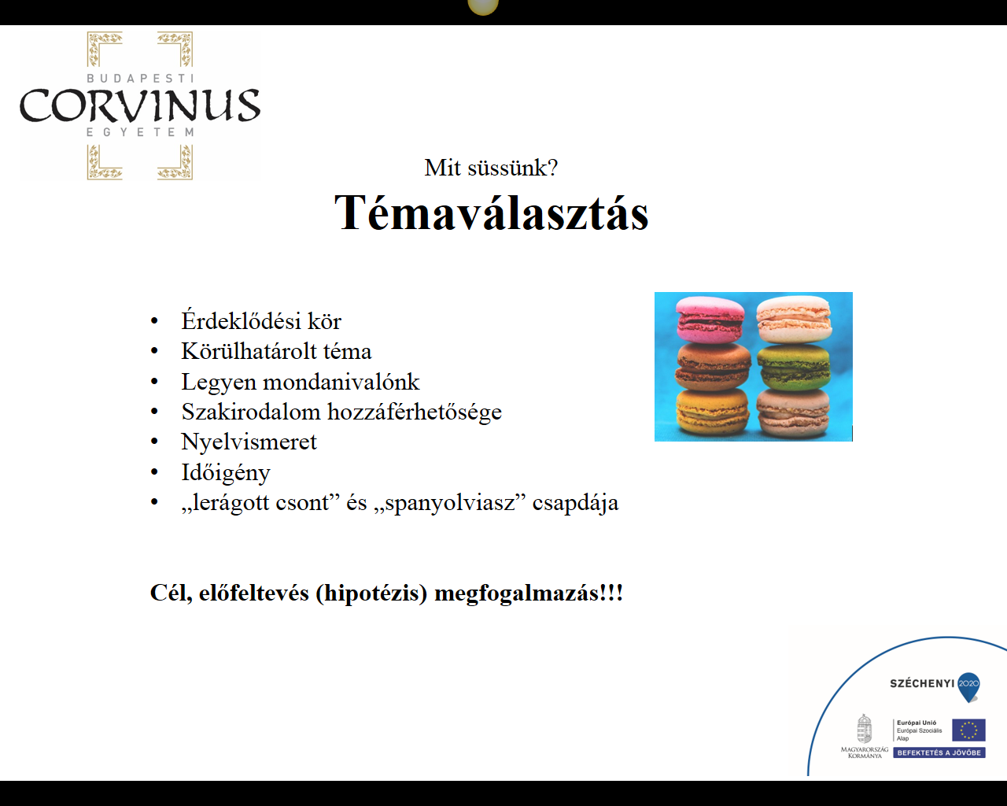

Jegyzetek

--------------------------------------------------------------------------------------------------------------------------------------------------------------------------------------------------------------------------------------------------------------------------------------------------------------------------------------------------------------------------------------------------------------------------------------------------------------------------------------------------------------------------------------------------------------------------------------------------------------------------------------------------------------------------------------------------------------------------------------------------------------------------------------------------------------------------------------------------------------------------------------------------------------------------------------------------------------------------------------------------------------------------------------------------------------------------------------------------------------------------------------------------------------------------------------------------------------------------------------------------------------------------------------------------------------------------------------------------------------------------------------------------------------------------------------------------------------------------------------------------------------------------------------------------------------------------------------------------------------------------------------------------------------------------------------------------------------------------------------------------------------------------------------------------------------------------------------------------------------------------------------------------------------------------------------------------------------------------------------------------------------------------------------------------------------------------------------------------------------------------------------------------------------------------------------------------------------------------------------------------------------------------------------------------------------------------------------------------------------------------------------------------------------------------------------------------------------------------------------------------------------------------------------------------------------------------------------------------------------------------------------------------------------------------------------------------

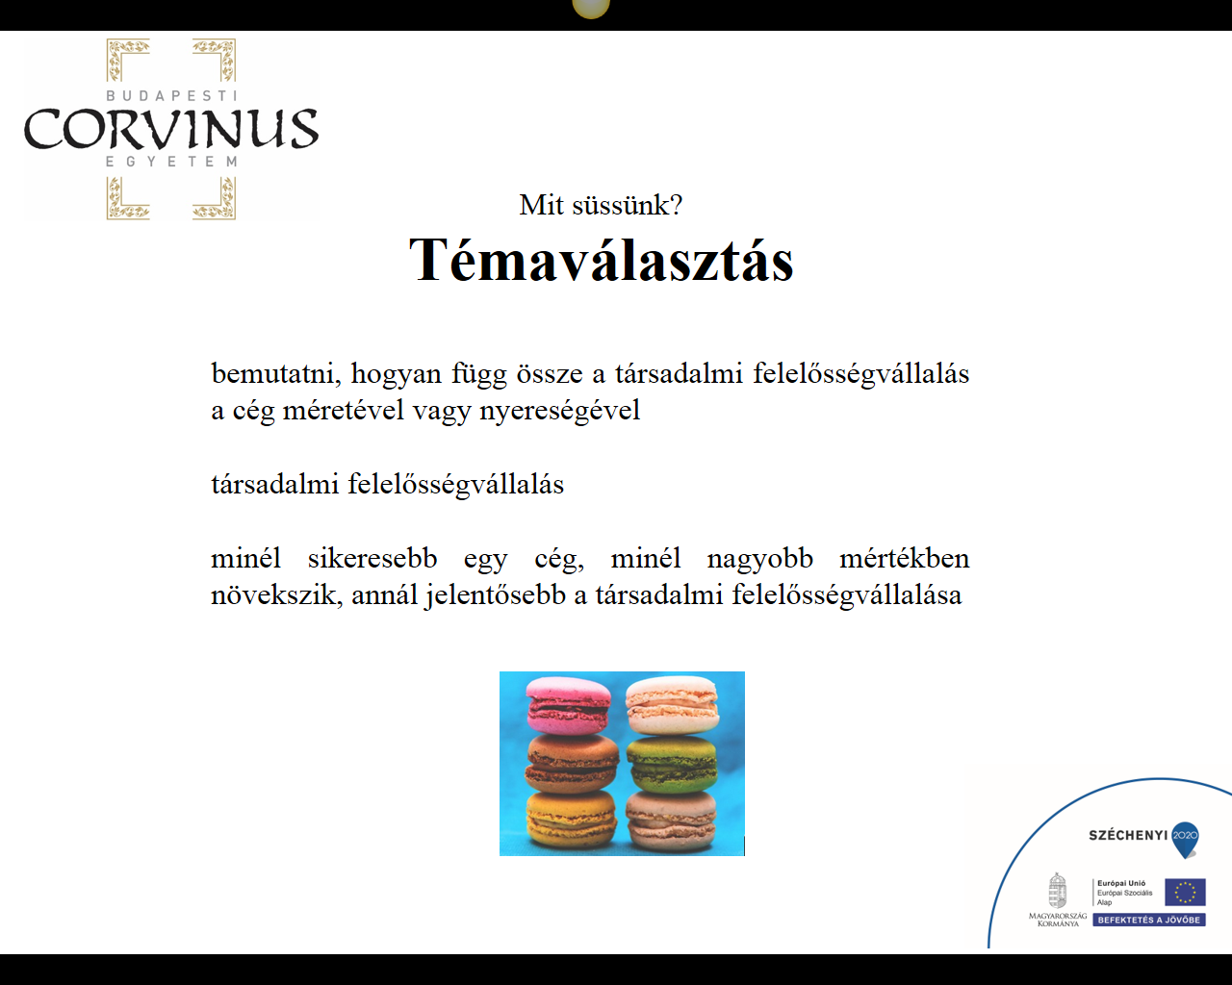

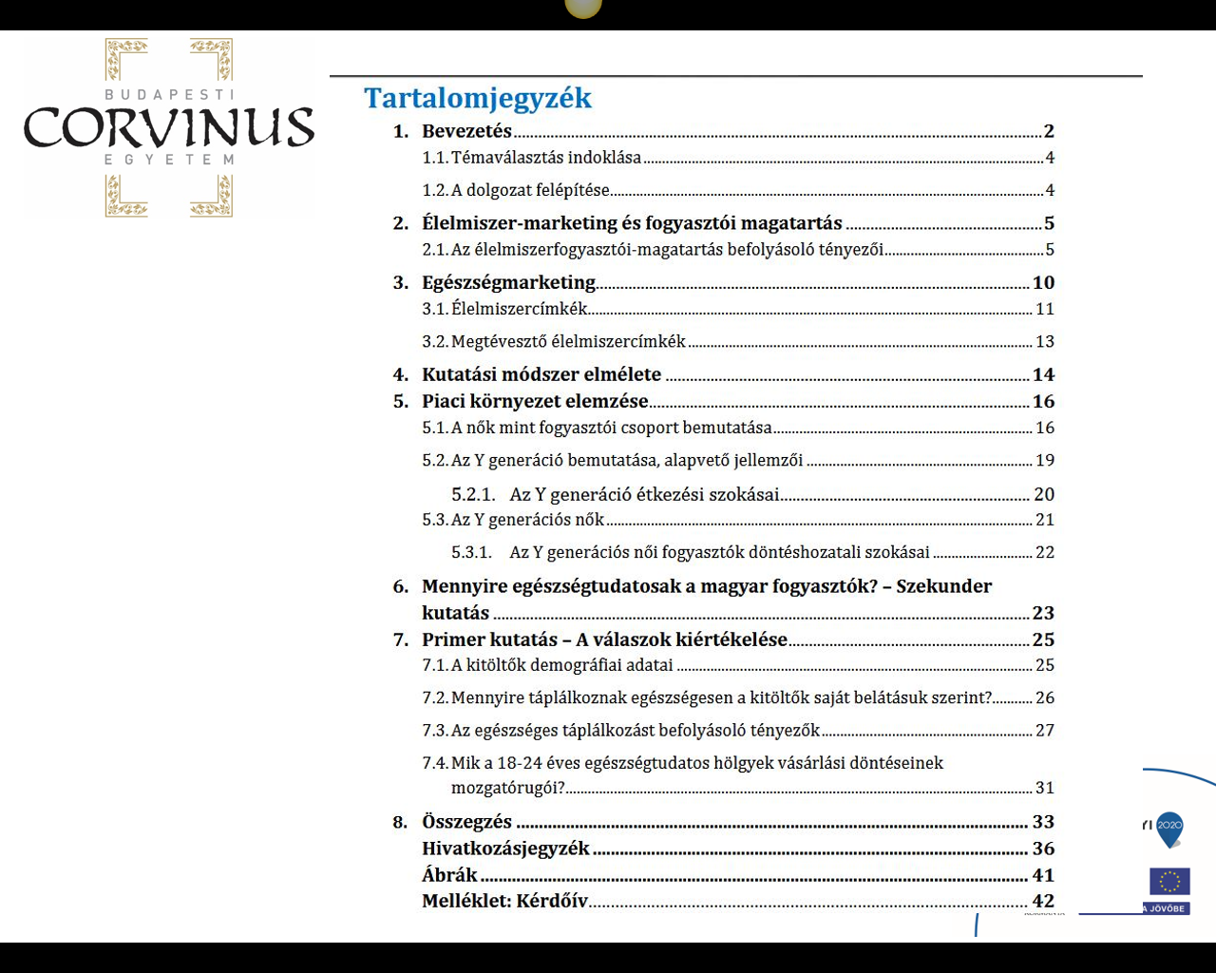

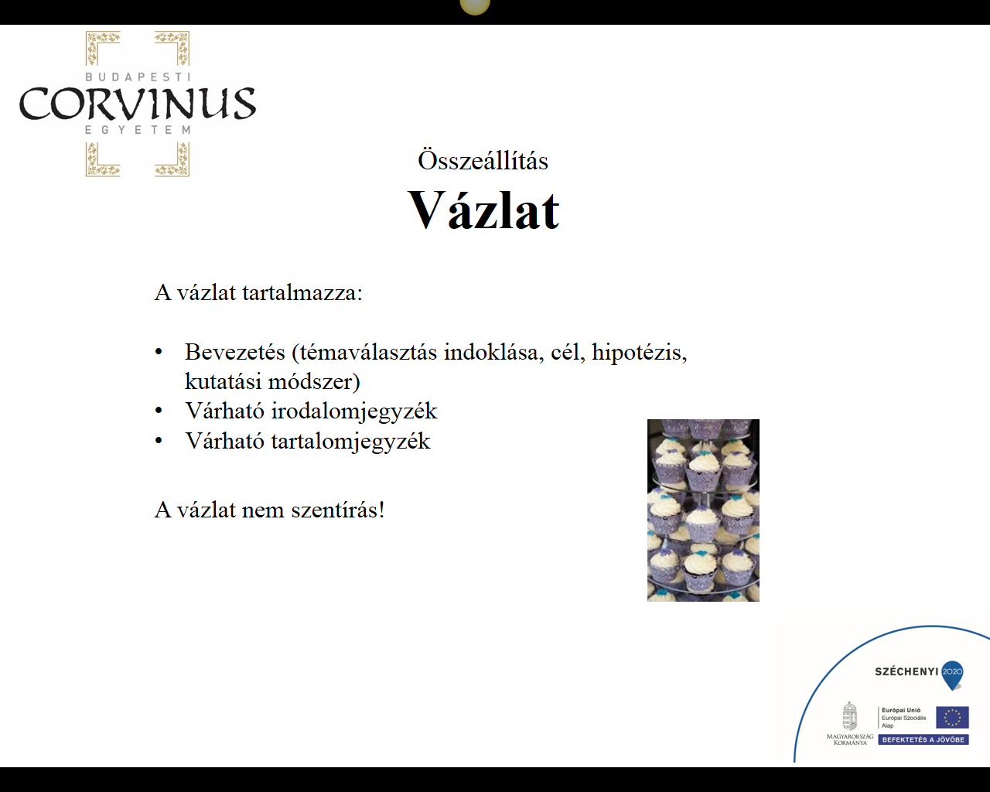

Jegyzetek

---------------------------------------------------------------------------------------------------------------------------------------------------------------------------------------------------------------------------------------------------------------------------------------------------------------------------------------------------------------------------------------------------------------------------------------------------------------------------------------------------------------------------------------------------------------------------------------------------------------------------------------------------------------------------------------------------------------------------------------------------------------------------------------------------------------------------------------------------------------------------------------------------------------------------------------------------------------------------------------------------------------------------------------------------------------------------------------------------------------------------------------------------------------------------------------------------------------------------------------------------------------------------------------------------------------------------------------------------------------------------------------------------------------------------------------------------------------------------------------------------------------------------------------------------------------------------------------------------------------------------------------------------------------------------------------------------------------------------------------------------------------------------------------------------------------------------------------------------------------------------------------------------------------------------------------------------------------------------------------------------------------------------------------------------------------------------------------------------------------------------------------------------------------------------------------------------------------------------------------------------------------------------------------------------------------------------------------------------------------------------------------------------------------------------------------------------------------------------------------------------------------------------------------------------------------------------------------

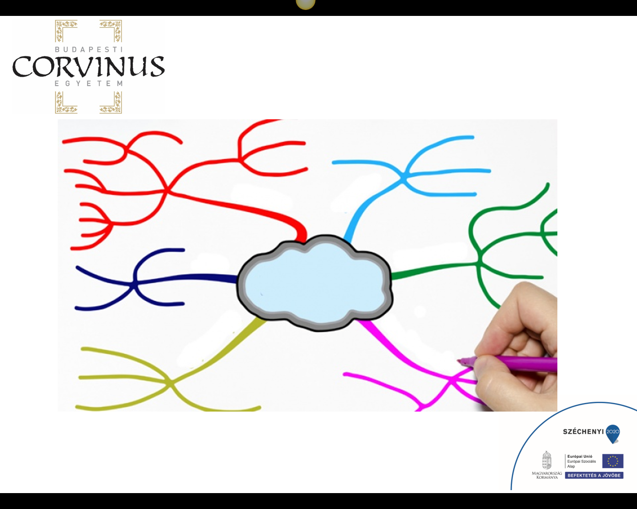

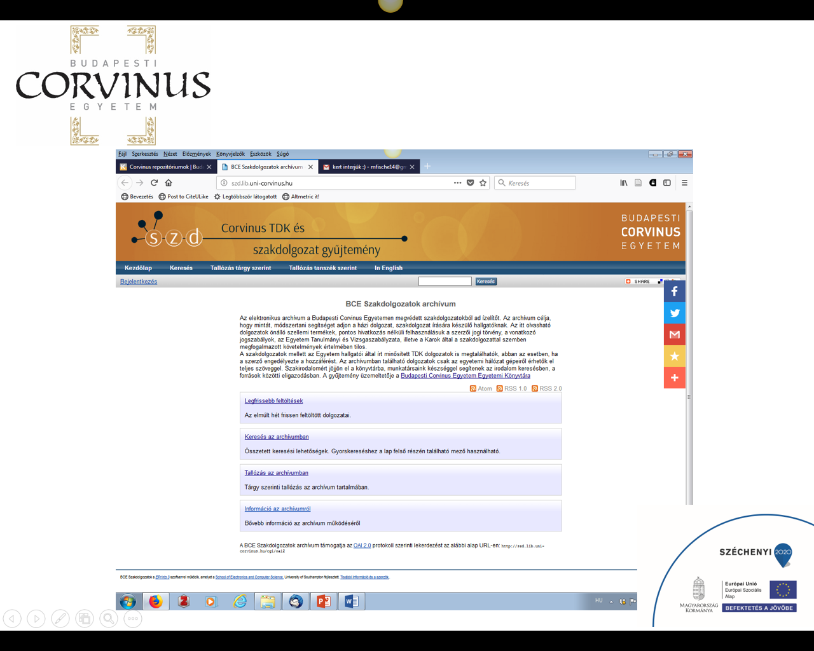

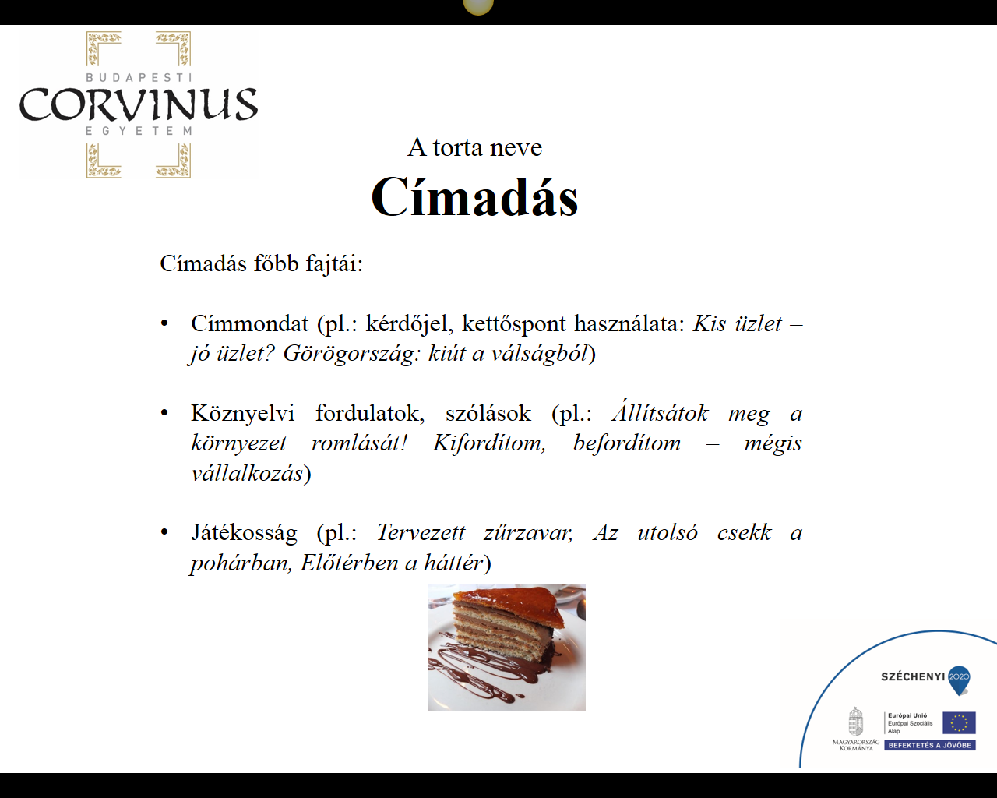

Jegyzetek

-------------------------------------------------------------------------------------------------------------------------------------------------------------------------------------------------------------------------------------------------------------------------------------------------------------------------------------------------------------------------------------------------------------------------------------------------------------------------------------------------------------------------------------------------------------------------------------------------------------------------------------------------------------------------------------------------------------------------------------------------------------------------------------------------------------------------------------------------------------------------------------------------------------------------------------------------------------------------------------------------------------------------------------------------------------------------------------------------------------------------------------------------------------------------------------------------------------------------------------------------------------------------------------------------------------------------------------------------------------------------------------------------------------------------------------------------------------------------------------------------------------------------------------------------------------------------------------------------------------------------------------------------------------------------------------------------------------------------------------------------------------------------------------------------------------------------------------------------------------------------------------------------------------------------------------------------------------------------------------------------------------------------------------------------------------------------------------------------------------------------------------------------------------------------------------------------------------------------------------------------------------------------------------------------------------------------------------------------------------------------------------------------------------------------------------------------------------------------------------------------------------------------------------------------------------------------------------------------------------

